Dog Breed Identification using Transfer Learning

Project Description:
In recent years, computer vision and deep learning have greatly improved image recognition tasks. Identifying dog breeds manually is challenging due to similar visual features, subtle texture differences, and variations in pose. Dog breed classification plays an important role in veterinary care, animal rescue and adoption platforms, pet-care recommendation systems, and wildlife research. Traditional image-processing methods are often time-consuming and less accurate. To address this, the proposed system uses deep learning with transfer learning based on MobileNetV2 to automatically classify dog breeds from images. The model applies CNN-based feature extraction to learn fine-grained visual patterns and deliver fast, accurate predictions through a web-based interface, enabling an accessible and intelligent solution for automated animal recognition.
Technical Architecture:
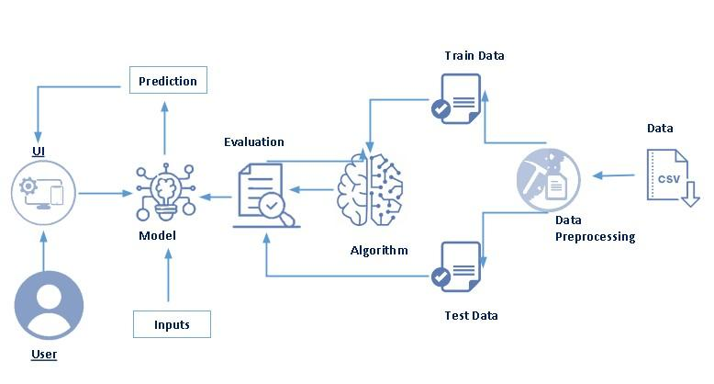

Pre requisites:
To complete this project, you must require the following software’s, concepts, and packages
- Anaconda Navigator is a free and open-source distribution of the Python and R programming languages for data science and machine learning related applications. It can be installed on Windows, Linux, and macOS. Conda is an open-source, cross-platform, package management system. Anaconda comes with so very nice tools like JupyterLab, Jupyter Notebook,QtConsole, Spyder, Glueviz, Orange, Rstudio, Visual Studio Code. For this project, we will be using Jupyter notebook and VS code.
- To install Anaconda navigator and to know how to use Jupyter Notebook & Spyder using Anaconda watch the video

- Link: Click here to watch the video

1. To build Machine learning models you must require the following packages

- Numpy:
It is an open-source numerical Python library. It contains a multidimensional array and matrix data structures and can be used to perform mathematical operations
- Scikit-learn:
It is a free machine learning library for Python. It features various algorithms like support vector machine, random forests, and k-neighbors, and it also supports Python numerical and scientific libraries like NumPy and SciPy
- Flask:
Web framework used for building Web applications
- Python packages:
open anaconda prompt as administrator
Type “pip install numpy” and click enter.
Type “pip install pandas” and click enter.
Type “pip install scikit-learn” and click enter.
Type “pip install tensorflow==2.12.0” and click enter.
Type “pip install keras==2.12.0” and click enter.
Type “pip install Flask” and click enter.
- Deep Learning Concepts

- CNN: A convolutional neural network is a class of deep neural networks, most commonly applied to analysing visual imagery. CNN Basic
- MobileNetV2:MobileNetV2 is a lightweight deep convolutional neural network architecture designed for efficient image classification.
It uses depth wise separable convolutions and inverted residual blocks to reduce computation while maintaining high accuracy.
In this project, MobileNetV2 is applied through transfer learning to accurately classify different dog breeds from images with faster training and lower resource usage.
- Flask: Flask is a popular Python web framework, meaning it is a third-party Python library used for developing web applications.
Flask Basics

Project Objectives:
By the end of this project you will:
- Know fundamental concepts and techniques of Convolutional Neural Network.
- Gain a broad understanding of image data.
- Know how to pre-process/clean the data using different data preprocessing techniques.
- K now how to build a web application using the Flask framework.

Project Flow:
- The user interacts with the UI (User Interface) to upload or choose a dog image.
- The selected image is processed and analyzed by the deep learning model integrated with the Flask application.
- A CNN-based MobileNetV2 transfer learning model analyzes the image, and the predicted dog breed is displayed on the Flask UI.
To accomplish this, the following activities and tasks are performed:

Data Collection
- Collect diverse dog breed images from public datasets such as Kaggle.
- Ensure sufficient images for each breed class.
Dataset Preparation
- Organize images into Train and Test folders.
- Maintain proper class-wise directory structure.
Data Preprocessing
- Import the ImageDataGenerator library.
- Configure ImageDataGenerator for:
  - Image resizing
  - Normalization
  - Data augmentation
- Apply ImageDataGenerator to training and testing datasets.
Model Building
- Import required TensorFlow / Keras libraries.
- Load MobileNetV2 pre-trained model (transfer learning).
- Freeze base layers and initialize the model.
- Add custom fully connected classification layers.
- Configure the learning process (optimizer, loss, metrics).

Model Training and Testing
- Train the model using the training dataset.
- Validate performance using the test dataset.
- Evaluate accuracy and prediction performance.
Model Saving
- Save the trained model in .h5 format for deployment and inference.
Application Development
- Create HTML templates for image upload and prediction display.
- Develop Flask backend code to:
  - Load the trained model
  - Accept uploaded images
  - Perform prediction
  - Display predicted dog breed on the UI.

Project Structure:
Create the Project folder which contains files as shown below
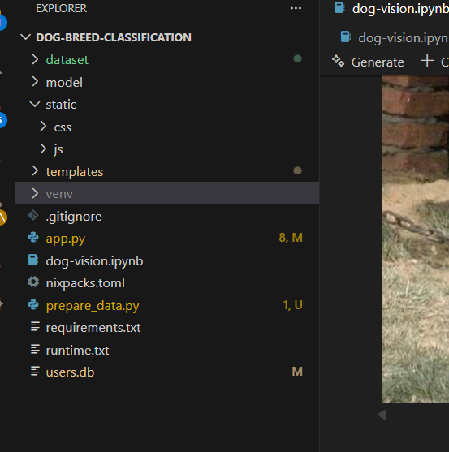

We are building a Flask-based web application that uses HTML pages stored inside the templates folder for the user interface and a Python script (app.py) to handle routing, prediction logic, and backend processing.

The trained deep learning model (MobileNetV2) is saved in .h5 format inside the model folder, and this saved model is loaded in the Flask application to perform dog breed prediction during runtime.

The project includes dataset preparation, model training scripts, and deployment configuration files:

prepare_data.py for organizing dataset images

dog-vision.ipynb / training code for model training using transfer learning

Deployment files (requirements, runtime, etc.)

Milestone 1: Data Collection & Image Preprocessing
Machine Learning and Deep Learning models strongly depend on high-quality data, which is the most important factor for accurate model training and prediction.
This phase focuses on collecting the required dog image dataset used for training the classification model.
Activity 1: Download the Dataset
There are many well-known open-source platforms for collecting datasets, such as:
- Kaggle
- UCI Machine Learning Repository
- Other public research datasets
For this project, we use the Dog Breed Identification dataset obtained from Kaggle, which contains thousands of dog images belonging to multiple breeds.
This dataset is used to train a deep learning model with transfer learning (MobileNetV2) for automatic dog breed prediction.
DatasetLink:
https://www.kaggle.com/competitions/dog-breed-identification/data?select=train
After downloading the dataset, the next step is to understand the structure, distribution, and characteristics of the dog breed images using visualization and analysis techniques.
Proper data understanding helps in selecting the right preprocessing methods and improves model performance.
Note: Many visualization techniques exist. In this project, only essential and meaningful techniques are used for analysis.
Activity : Importing the Libraries
The required Python libraries are imported for data handling, visualization, and image processing, such as:
- NumPy – numerical operations
- Pandas – reading labels and dataset information
- TensorFlow / Keras – deep learning and image processing
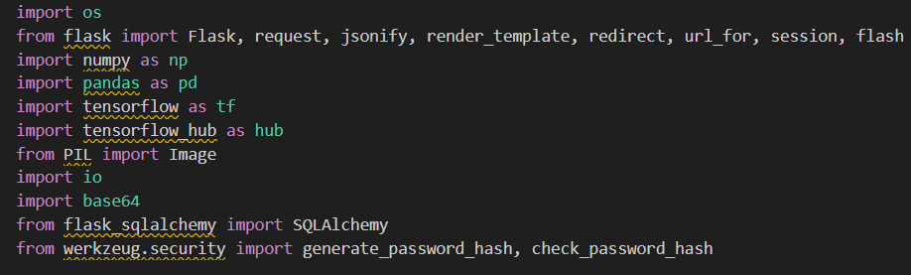
Activity : Reading the Dataset
The dog breed dataset contains:
- Images of dogs
- labels.csv file mapping image IDs to breed names
The dataset is read using Pandas read_csv() for labels and directory-based image loading for training.
This helps in:
- Understanding number of images per breed
- Checking missing or imbalanced classes
- Preparing data for preprocessing
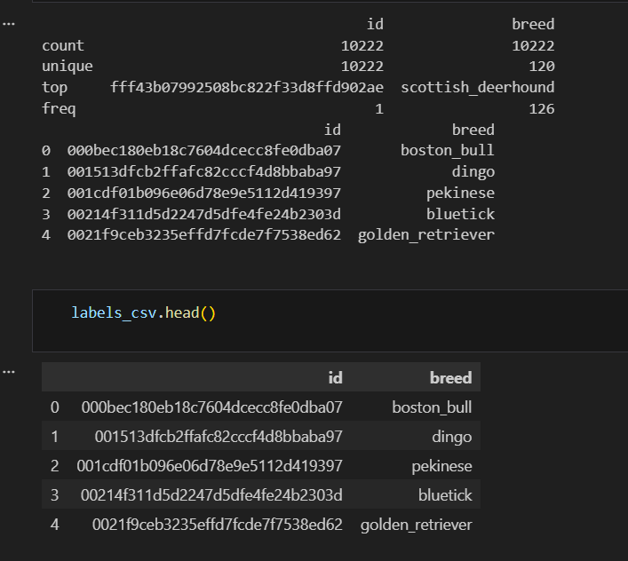
Activity : Descriptive Analysis
Descriptive statistics summarize the dataset using:
- Total number of images
- Number of dog breeds (classes)
- Minimum, maximum, and average images per class
Using Pandas describe() and dataset inspection, we confirm:
- Dataset is suitable for deep learning classification
- Requires normalization and augmentation before training
Activity : Organizing the Images into Different Classes
In this step, the Dog Breed Identification dataset collected from Kaggle is prepared for training the deep learning model.
Each dog image is mapped to its corresponding breed label using the labels.csv file provided in the dataset.
Based on these labels, the images are arranged into separate folders for each dog breed, creating a structured directory format required for CNN training.
This organization enables the ImageDataGenerator and MobileNetV2 transfer learning model to correctly learn visual patterns for multiclass dog breed classification.

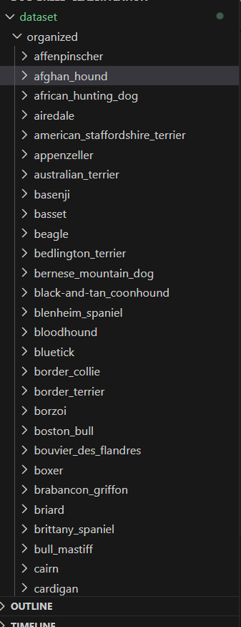

Activity : Import Image Preprocessing Utilities
In this project, instead of using ImageDataGenerator, the system directly imports TensorFlow/Keras image preprocessing utilities to prepare images for prediction using the MobileNetV2 transfer learning model.
These utilities perform:
- Image loading from the uploaded file
- Resizing to 224 × 224 pixels (MobileNetV2 input size)
- Conversion to array format
- Normalization using MobileNetV2 preprocessing function

Activity : Configure Image Preprocessing Pipeline
In this project, instead of configuring an ImageDataGenerator, the preprocessing pipeline is designed specifically for MobileNetV2 transfer learning inference.
The configuration includes:
- Loading the uploaded dog image using PIL / TensorFlow utilities
- Resizing the image to 224 × 224 pixels, which is the required input size for MobileNetV2
- Converting the image into a numerical array suitable for neural network processing
- Applying MobileNetV2 preprocessing normalization, which scales pixel values and prepares the image in the same format used during model training
This preprocessing pipeline ensures:
- Compatibility with the pre-trained MobileNetV2 model
- Fast real-time prediction inside the Flask web application
- Consistent and reliable classification performance
Thus, the project replaces traditional ImageDataGenerator configuration with a direct MobileNetV2-specific preprocessing workflow optimized for deployment and inference.

Activity : Splitting data into train and test
In this project, traditional ImageDataGenerator-based dataset loading is not used.
Instead, the dataset is handled using direct file paths and labels, followed by splitting with scikit-learn.
Process followed
- Image paths and corresponding breed labels are stored in arrays.
- The dataset is divided into training and validation sets using:
  - train_test_split() from sklearn.model_selection
  - 80% data for training
  - 20% data for validation
  - Random state is fixed for reproducibility.
- The resulting split produces:
  - X_train, y_train → Training images and labels
  - X_val, y_val → Validation images and labels
This approach provides:
- Simple and memory-efficient dataset handling
- Better control over training and validation distribution
- Compatibility with MobileNetV2 preprocessing pipeline
Thus, instead of applying ImageDataGenerator functionality,
the project relies on manual dataset splitting and preprocessing,
which is sufficient for transfer learning-based dog breed classification
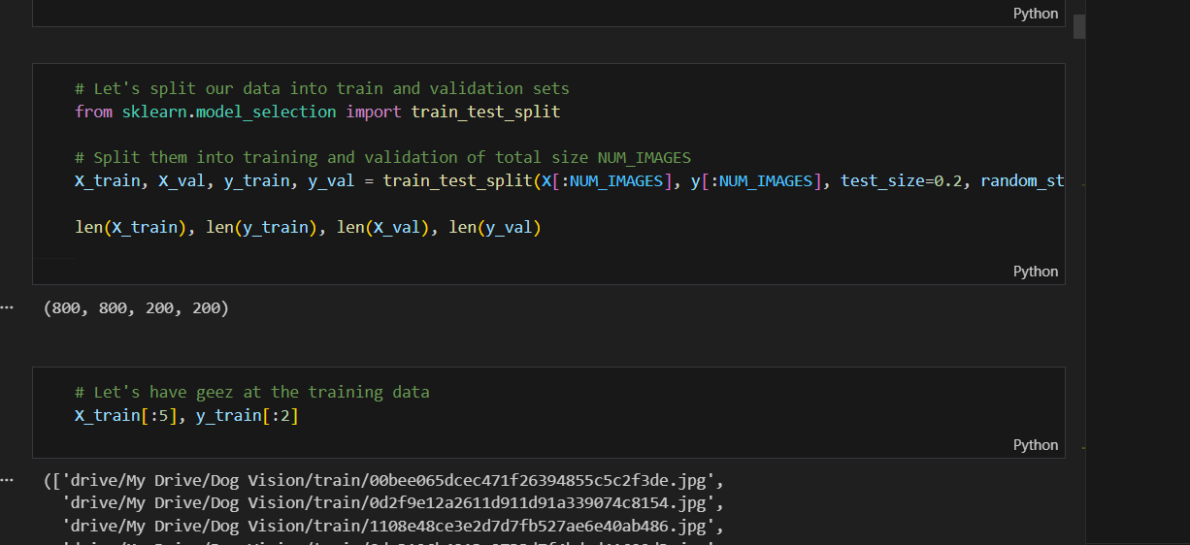

Milestone 2: Model Building
Now our data is cleaned and it’s time to build the model. We can train our data on different algorithms. for this project we are applying four classification algorithms. The best model is saved based on its performance.
Activity 1: Importing the Model Building Libraries
To construct the deep learning model, the required libraries are imported, including:
- TensorFlow / Keras for neural network construction
- NumPy for numerical operations
- MobileNetV2 from tensorflow.keras.applications for transfer learning
- Image preprocessing utilities for resizing and normalization
These libraries enable efficient image-based classification using CNN architecture.
Activity 2: Importing the MobileNetV2 Pre-trained Model
Instead of VGG19, this project uses MobileNetV2, a lightweight and efficient convolutional neural network designed for image classification.
- Pre-trained on ImageNet dataset
- Provides high accuracy with low computational cost
- Suitable for real-time web deployment
Only the feature extraction layers are reused, enabling transfer learning.
Activity 3: Initializing the Transfer Learning Model
The MobileNetV2 base model is loaded with:
- Pre-trained ImageNet weights
- Top layers removed (include_top=False)
- Input image size configured to 224 × 224
This allows the network to learn dog-breed-specific features while retaining powerful generic visual features.
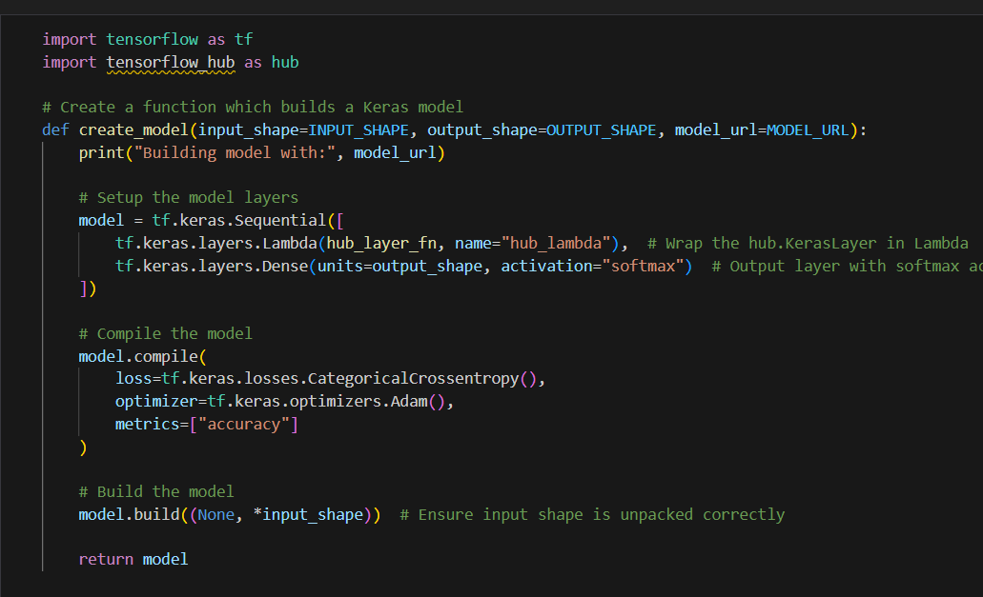
Activity 4: Adding Classification Layer & Model Summary
After loading the MobileNetV2 model, a Dense softmax classification layer is added to match the 120 dog breed classes.
This connects the feature extractor to the final prediction output.
The model summary is then used to verify:
- Correct layer structure and output shapes
- Total and trainable parameters
- Readiness of the model for training
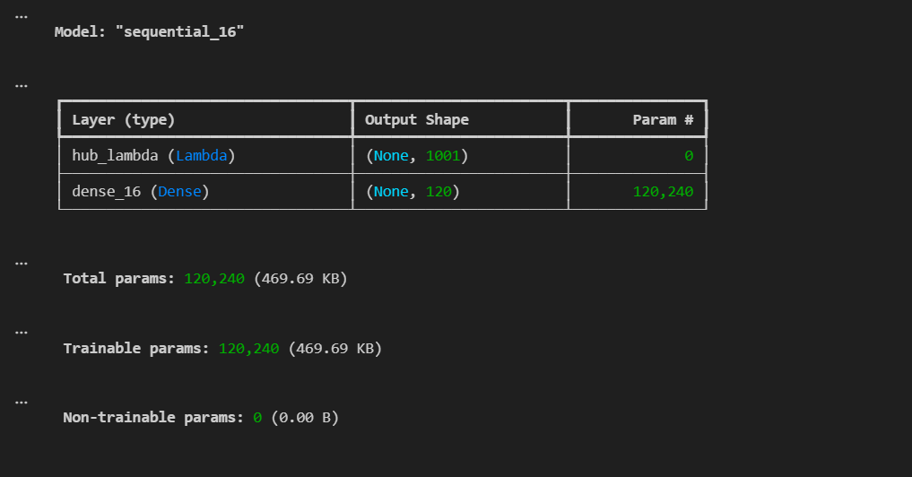
Activity 5: Configuring the Learning Process
The model training configuration includes:
- Loss function: Categorical Cross-Entropy
- Optimizer: Adam optimizer
- Evaluation metric: Accuracy
This setup ensures stable convergence and accurate multi-class classification.
Activity 6: Training the Model
The MobileNetV2-based deep learning model is trained using the prepared training and validationdatasets.
During training, the system learns breed-specific visual patterns from images over multiple epochs.
Accuracy and loss values are monitored to evaluate performance and ensure proper learning.
Early stopping is applied to prevent overfitting and improve generalization.
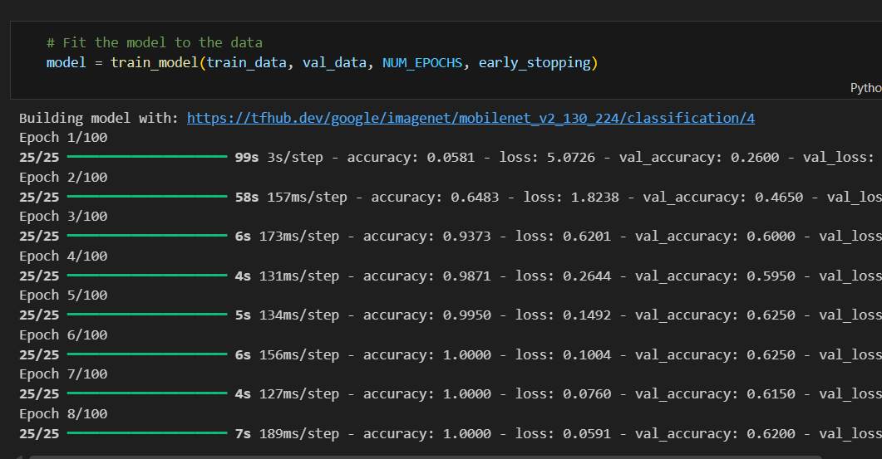

Activity 7: Saving the Trained Model
After successful training:
- The trained MobileNetV2-based model is saved.
- This saved model is later loaded inside the Flask application
- Enables real-time prediction without retraining

Activity 8: Testing and Prediction
The saved model is evaluated using:
- Validation images not seen during training
- Prediction probabilities generated via Softmax output
- Final dog breed label displayed in the web interface
This confirms the model’s generalization capability and real-time usability.
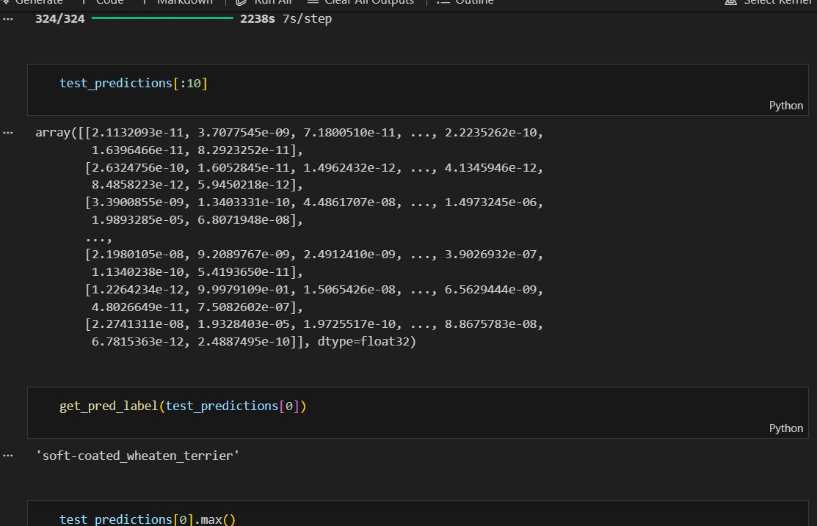

Milestone 3: Application Building
In this section, we will be building a web application that is integrated to the model we built. A UI is provided for the uses where We upload an image for predicting the breed of the dog. The Image is given to the saved model and prediction is showcased on the UI.
This section has the following tasks
- Building HTML Pages
- Building serverside script
Activity1: Create HTML Pages
Design simple and user-friendly web pages using HTML and CSS.
These pages allow users to upload a dog image and view the predicted breed result clearly.
For this project create three HTML files namely
- home.html
- contact.html
- about.html
- index.html
- login.html
- signup.html
and save them in templates folder.
Let’s see how our home.html page looks like:
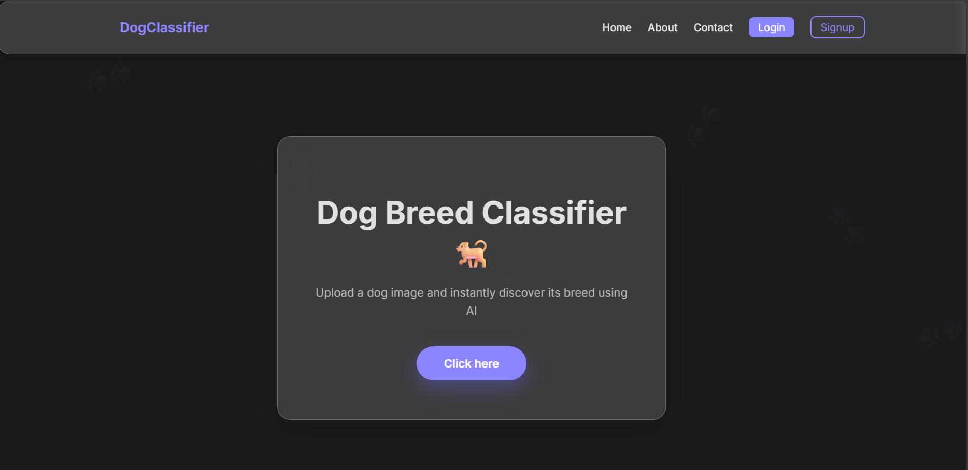
Let’s see how our contact.html page looks like:
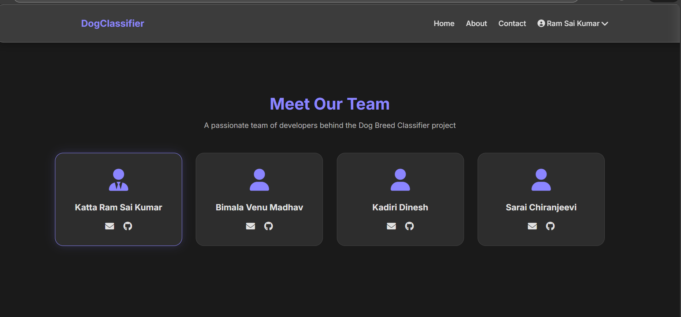

Lets look how our about.html file looks like:
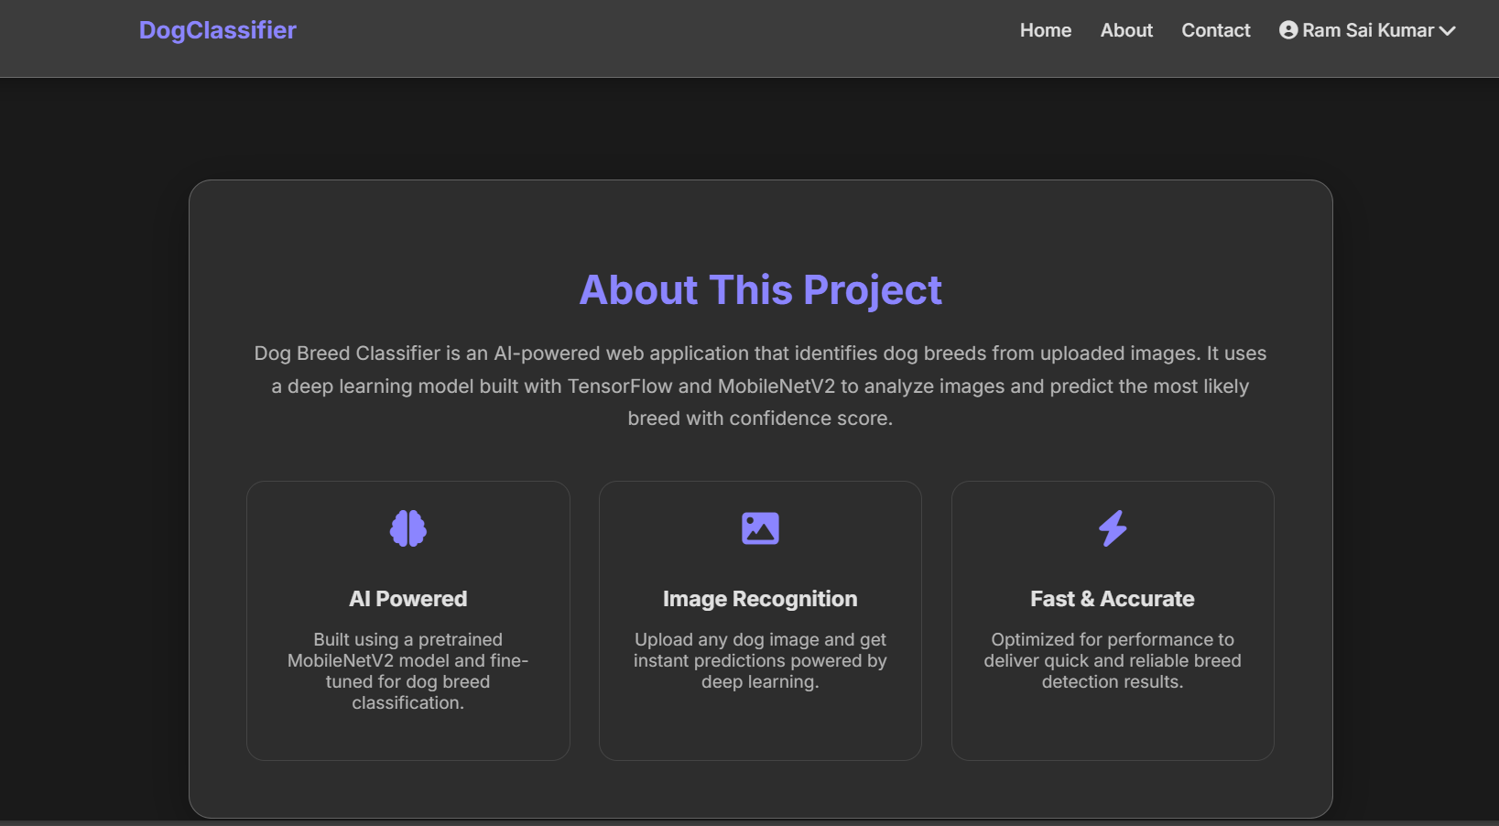
Lets Look how our index.html page looks like:
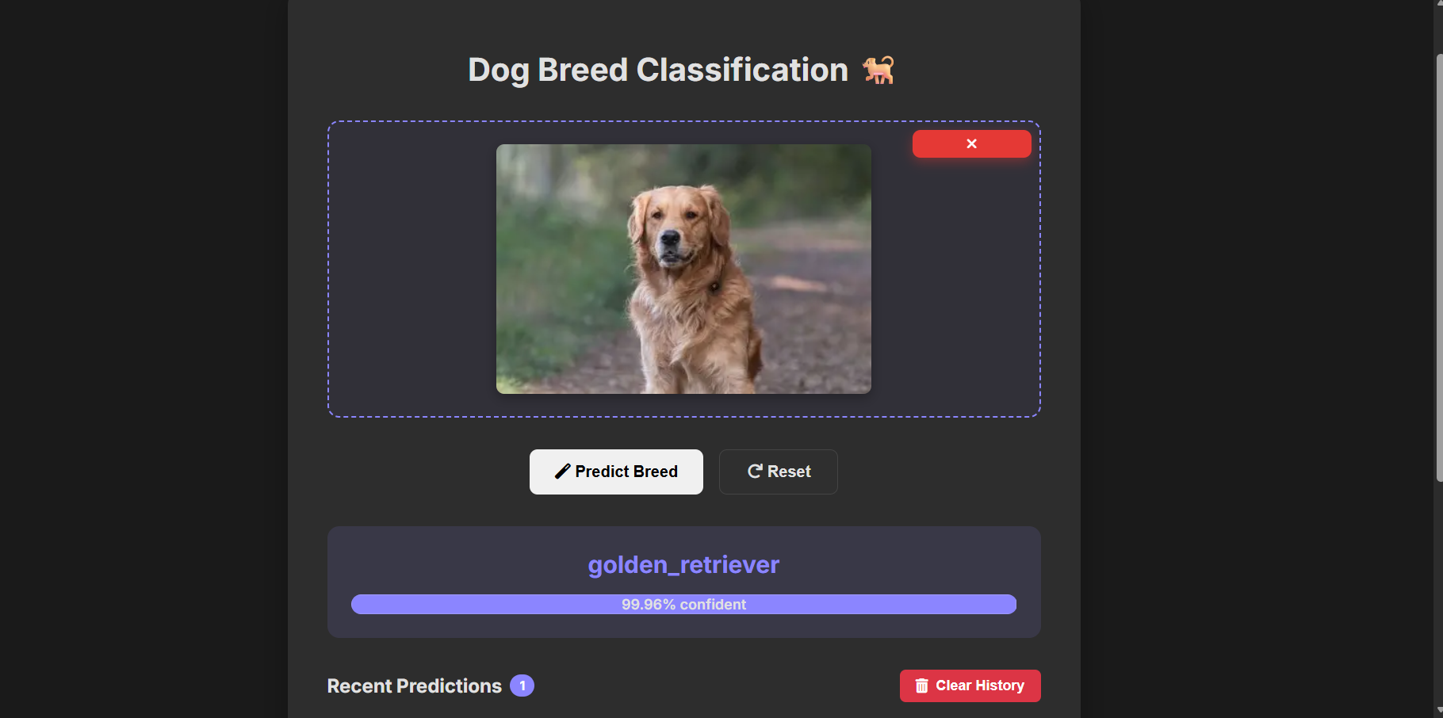
Lets Look how our login.html page looks like:
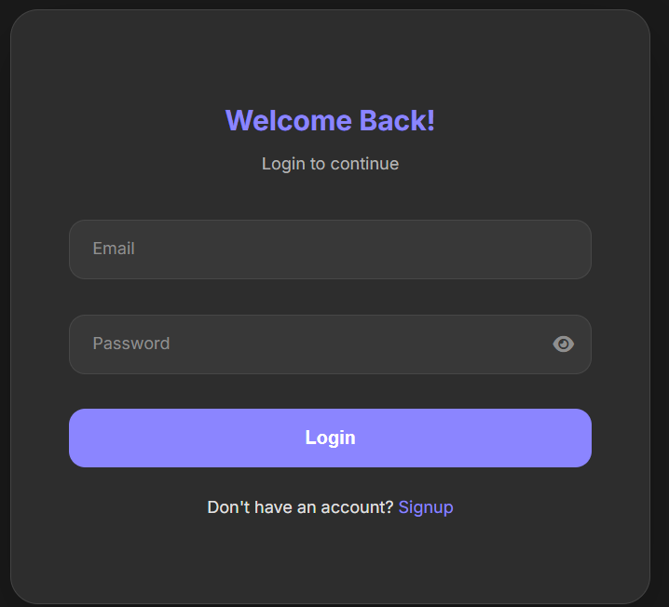
Lets Look how our signup.html page looks like:
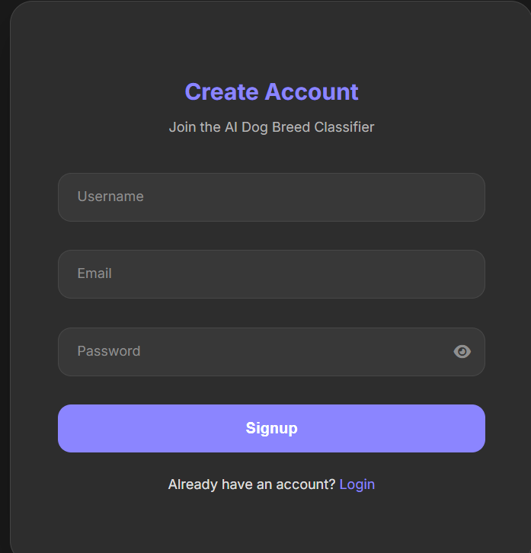
Activity 2: Build Python Code
Develop the backend using Python and the Flask framework to handle image upload, model loading, and prediction processing.

Importing Libraries
Required libraries such as Flask, TensorFlow/Keras, NumPy, and image preprocessing modules are imported to support model inference and web interaction.
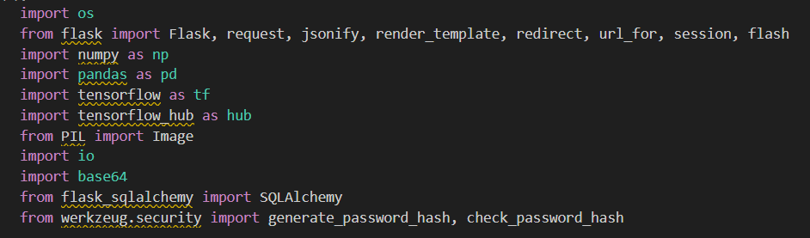

Creating Flask Application and Loading Model
A Flask app is initialized, and the trained MobileNetV2 dog breed classification model is loaded using the load_model() method to enable real-time predictions.
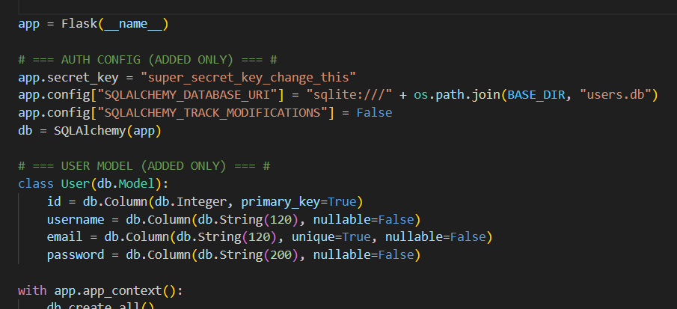

Routing to HTML Page
Flask routes are defined to connect backend logic with frontend pages, allowing users to upload images and receive prediction results on the web interface.
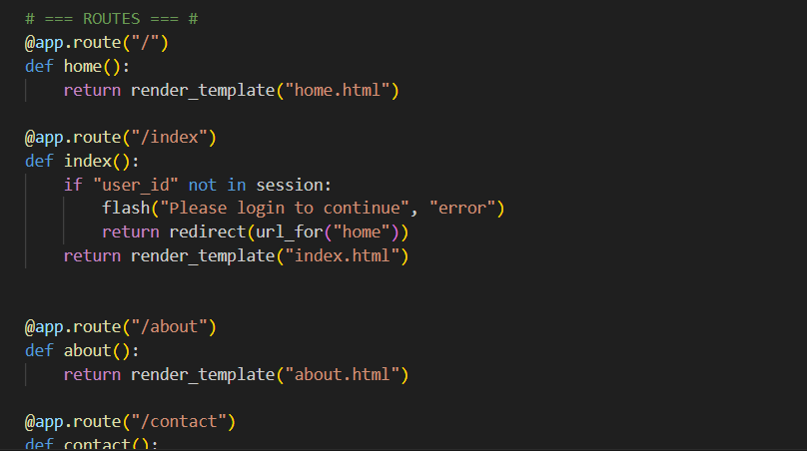

Run the Application
Finally, the Flask server is executed locally or deployed online, enabling users to access the dog breed prediction system through a browser.
